FY2023

Activity Report

March 2023

EROPA Local Government Center

(Local Autonomy College,

Ministry of Internal Affairs and Communications)

1.　Attendance at the EROPA Conference

The 2023 EROPA Conference was held in Hanoi, Viet Nam over a four-day period from September 16 (Mon.) to 19 (Thurs.), 2023 on the theme “The Role of Public Governance in Socio-Economic Recovery and Development Towards the Sustainable Development Goals.” Thirteen people listed in the table below attended the conference from Japan, including state representative Miyachi Toshiaki, President of the Local Autonomy College and two Local Government Center advisers; Takada Hirofumi, Vice-President at the National Graduate Institute for Policy Studies and Kikuchi Masao, Professor at Meiji University.



Since FY2014, EROPA Local Government Center has implemented the EROPA Research Conference Presenters Grant system that provides grants for young Japanese researchers who present articles on Japanese local governance at EROPA conferences. In FY2023, Nakagawa Go, Research Associate, Japan Municipal Research Center, and Terada Taketo, Ph.D. Candidate, Waseda University received grants and attended the conference to make their presentations at parallel sessions.

< Day 1 >

On the first day, October 16, the 68th Executive Council Meeting began at 16:00. At the meeting, Dr. Alex Brillantes, Secretary General of EROPA reported on the activities of EROPA, followed by other activity reports by each of the technical centers, Dr. Kristoffer B. Berse, deputy editor of the editorial committee for ARPA (EROPA’s organizational bulletin) and Dr. Kikuchi Masao, Professor at Meiji University, chair of the Future Plans and Programs Committee. Besides, the following was discussed; Membership Application and Approval Process, Method and Frequency of the Executive Council Meeting, Membership Arrears, Revitalization of ARPA and Membership Fee Arrears Issues for India and Iran and so on.

At the meeting, President Miyachi made a report on the activities of EROPA Local Government Center, referring to the results of Local Governance Training (discussed below), which is implemented jointly with the Japan International Cooperation Agency (JICA), Half-day Local Autonomy College tour for foreign visitors and Comparative Studies, which is a collection of comparative articles on public administration written by researchers mainly from EROPA member states.

< Days 2 to 4 >

At the beginning of the opening ceremony on October 17, H.E. Pham Thi Thanh Tra, Minister of Home Affairs of Viet Nam and Dr. Alex Brillantes, Secretary-General of EROPA, delivered welcoming speeches for the Hanoi conference. Then, President Miyachi made a greeting speech as representative of Japan during the General AssemblyⅠwhich was held after the ceremony.

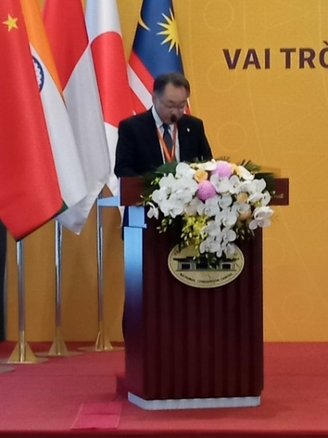

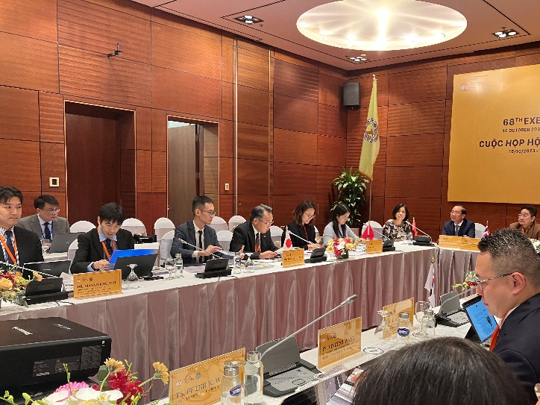

the 68th Executive Council Meeting President Miyachi making a greeting speech

On October 18, parallel sessions were held on each sub-theme, at which researchers made their presentations moderated by the coordinators. Researchers from Japan and their respective presentations were as follows:

1) Research Associate Nakagawa at Japan Municipal Research Center (Recipient of article presenter grant)

“A Study of Political Corruptions from The Perspective of Economic Growth and Socio-Political

Function”

2) Ph.D. Candidate Terada at Waseda University (Recipient of article presenter grant)

“An empirical analysis of the trade-off hypothesis between homeownership and welfare: The case of

Japanese local government”

3) Professor Inatsugu at Waseda University

“Public Personnel Administration of the Local Government in Japan:

How the Central Government Controls the Total Personnel Cost Nationwide”

4) Professor Kamiko at Ritsumeikan University

“Introduction of Whistle-blowing System in Municipalities in Kyoto Prefecture, Japan’’

5) Associate Professor Nishimura at Osaka University

“An Empirical Study of the Relations Between Residents’ Trust and Performance of Local Government:

Case of the Philippines”

6) Professor Fujiwara at Otemon Gakuin University

“Sustainable Governance for Immigration Management in Japan: The Role of Public Introduction in the

Provision of Japanese Language Education”

General AssemblyⅡ and Closing Ceremony were held in the afternoon of October 19. At the General AssemblyⅡ, Dr. Kikuchi reported on the results of Future Plans and Programs Committee, before Dr. Kristroffer gave a summary of the conference. Subsequently, a presenter from Malaysia and two presenters from Viet Nam were given Best Paper Award and a female presenter from Philippines was selected as the Women Award winner. Finally, the closing remark was made by Dr. Trieu Van Cuong, Vice Minister, Minister of Home Affairs, Viet Nam and the conference came to an end.

2.　Implementation of Local Governance Training

This training program is implemented jointly with the Japan International Cooperation Agency (JICA) every year based on EROPA’s request, with the aim of helping to boost standards for local public administration mainly in the EROPA member countries. We accept as trainees those public employees from developing countries who are engaged in tasks related to local governance, holding courses for them at Local Autonomy College, and providing them with on-site training at Japanese local public agencies. FY2023 marked its 58th implementation. Each year about 15 trainees are accepted, with the total number of people accepted since the first implementation concurrent with the formation of EROPA Local Government Center in October 1964 reaching 666 people from 70 countries by FY2023.

In FY2023, training was implemented for 12 trainees from 10 countries (4 trainees from Asian and Africa countries respectively and 2 trainees from East Europe countries and South America countries) over a 5-week period from October 25 to November 28.

The curriculum was arranged with the lectures on local administrative systems, etc, article writing, report presentation and on-site training at local public agencies. University professors and other distinguished persons who are well versed in each field served as the instructors.



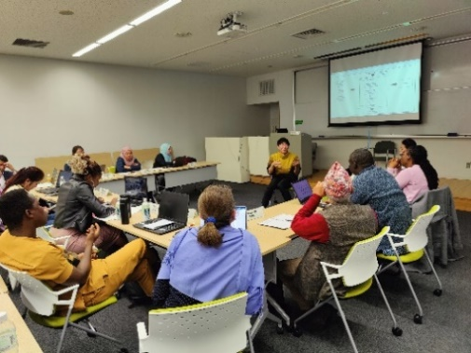

The lecture on Nature of New Administration / Civil Society Collaboration by Prof. Ogawa, Kwansei Gakuin University

Black Wall Square in Nagahama City

“Opening Ceremony” was held on October 26 when the training started, followed by “Inception Report Presentation Meeting” on October 27, “Recap Discussion on lectures and visits” during the middle phase of the training on November 20, “Assessment Report Presentation” at the end of the training on November 27, and “Closing Ceremony” on November 28.

Inception Reports are summarized reports that every trainee submits before beginning of training and they include both the analyses on the public administration challenges faced by their organizations and the initiatives of their countries to address such challenges.

On the other hand, Assessment Reports come about as a result of the training, and they compare Japan’s regional system with the systems in each trainee’s home country, providing suggestions aimed at solving their own country’s challenges for public administration.

Assessment Report Presentation

In FY2023, on-site training was conducted in the Kanto region (Tachikawa City, Koto City, Chiba City, Katori City, and Narita City), where trainees listened to explanations about such initiatives as cultural promotion, history of waste disposal, Ariake Area development, Makuhari New City, decreasing birthrate & aging population, and achievements & challenges of international city "Narita." The trainees extended their visit to Shiga Prefecture and Mie Prefecture (Otsu City, Omi Hachiman City, Nagahama City, Tsu City and Yokkaichi City), where trainees listened to explanations about digital innovation (Otsu City), observation of Kirihara Elementary School, Nagahama City's vision of industrial promotion, promotional measures for the southern region of Mie Prefecture and history of Yokkaichi asthma.



**3. Editing of Comparative Studies of Public Administration**

This is a collection of comparative articles in English on local public administration written by researchers mainly from EROPA member countries. In accordance with a 1981 general assembly resolution, the collection of articles is published with the aim of promoting comparative research on local public administration in the Asia-Pacific region. Since 1984, it has been compiled once every two to three years. The copies are distributed to EROPA member countries, EROPA group and individual members in Japan, Ministry of Internal Affairs and Communications, related organizations, local public entities, researchers, and others.

In June 2020, Vol. 13 was published under the editorial board consisting of 5 members; Nakamura Akira, Professor Emeritus at Meiji University; Agata Koichiro, Professor at Waseda University, Takada Hirofumi, Vice-President at the National Graduate Institute for Policy Studies, Koike Osamu, Professor at Yokohama National University and Kikuchi Masao, then-Associate Professor at Meiji University. The theme was “Local Governance in the Age of technology Transformation and Global Uncertainty.”

In FY 2023, Local Government Center launched the editorial committee with the aim of discussing the themes of the issue and selecting the writers in order to publish Vol. 14 in FY 2024. The members of the committee are Nakamura Akira, Professor Emeritus at Meiji University; Agata Koichiro, Professor at Waseda University, Takada Hirofumi, Vice-President at the National Graduate Institute for Policy Studies, Kikuchi Masao, Professor at Meiji University; Jiannan Wu, Professor at Shanghai Jiao Tong University and Maria Fe Villamejor-Mendoza, Professor at the University of the Philippines Diliman.

<Past Issues Published>

Vol. 1 ｢The Local Public Administration in Asian and Pacific Countries｣ (Year 1984)

Vol. 2 ｢The Training System in the Public Service｣ (Year 1986)

Vol. 3 ｢The Role of Local Government in the Development of Depopulated Rural Areas｣ (Year 1990)

Vol. 4 ｢The Role of Residents, Non-governmental Organizations and Quasi-public Agencies in Local Government｣ (Year 1992)

Vol. 5 ｢Human Resource Development in Public Administration｣ (Year 1994)

Vol. 6 ｢Reforming Government: New Concepts and Practices in Local Public Administration｣ (Year 1998)

Vol. 7 ｢Local Governance and National Development｣ (Year 2001)

Vol. 8 ｢Public Reform, Policy Change, and New Public Management: From the Asia and Pacific Perspective｣ (Year 2004)

Vol. 9 ｢Civil Society and Local Governance｣ (Year 2006)

Vol. 10 ｢Local governance under stress: Fiscal Retrenchment and Expanding Public Demands on Government｣ (Year 2009)

Vol. 11 ｢Integrated Human Capacity Building In the Age of Decentralization｣ (Year 2012)

Vol. 12 ｢Enhancing the Quality of Local Governance: Institutionalization, Capacity Building and Inter-Governmental Relations｣ (Year 2015)

　Vol. 13「Local Governance in the Age of technology Transformation and Global Uncertainty」（Year 2020）

**4.　Local Autonomy College Tours**

In addition to the Local Governance Training discussed in the above Section 2, Local Autonomy College conducts half-day and full-day training sessions as needed for public employees and researchers from overseas.

The public employees and researchers were accepted as below.

|  |  |  |  |
| --- | --- | --- | --- |
| Year | Number of Times | Number of Persons | Participating Countries |
| 2019 | 7 | 74 | Myanmar, Bangladesh, China, Malaysia |
| 2021 | 1 | 8 | Philippines, Nepal, Cambodia, Viet Nam |
| 2023 | 5 | 47 | Philippines, Nepal, Vie Nam, Hong  Kong, Taiwan, China, Bangladesh,  Laos, Eritrea |

**5.　Local Governance Textbook (English)**

The Local Governance Textbook is an English teaching resource on local governance in Japan created for Local Governance Training, covering the topics of local public administration systems, local public employee systems, election systems, local fiscal administration systems, local public enterprise systems and local taxation systems.